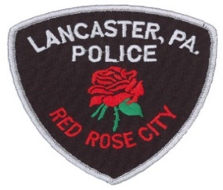
Please help our Lancaster City Work Better,
Smarter and more efficiently.
The Lancaster City Police Foundation is an independent charitable non-profit corporation formed on September 11, 2003. The Foundation’s purpose is to promote a safe environment and neighborhood for the residents, workers and visitors of Lancaster, Pa. Its objectives are to enhance the services of the Lancaster City Police Department and work with the Police to:

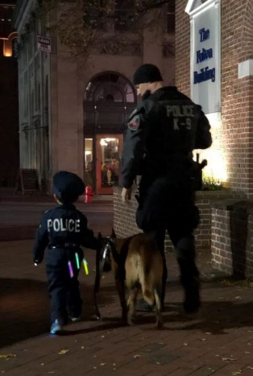
- Promote civic spirit in support of public safety and security
- Enhance public awareness of safety issues (such as parent watch,
neighborhood watch, theft prevention, bicycle safety, seat belt use)
- Raise funds to provide equipment to make Police work safer and more effective (such as Kevlar vests, communications equipment, patrol bicycles, etc.)
- Educate children and young adults about safety issues in schools
and other local settings
- Please make your commitment to Public Safety.
Enclosed is a contribution of $___________________
To the Lancaster City Police Foundation. Your contribution is tax deductible
Under section 501(c) (3) of the IRS code.
Please check one:
Unrestricted Donation For Mounted Patrol Support
For Canine Support For PAL (Police Athletic League)
Contribution Recognition:
$10+ Patrol
$50+ Sergeant
$160+ Lieutenant
$400+ Captain
$1000+ Chief

Print Name or Company: __________________________________________________

Address: ________________________________________________________________

City, State, Zip: ___________________________________________________________
Email: __________________________________ Phone: __________________________
(Your contact information is kept confidential and is not shared with any other organization)

This gift is made in honor of _______________________________________________________
I would like this gift to remain anonymous

